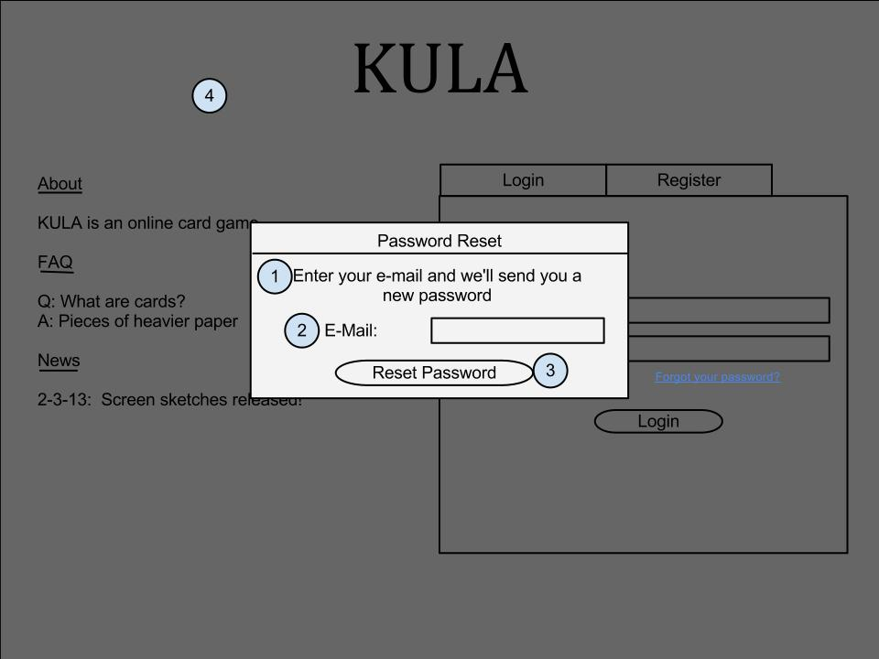This screen is accessed when the user clicks on the forgot password link on the login screen. They’re taken here where they can confirm their e-mail address to get a password reset e-mail sent to them.

Forgot Password Screen – Trevor Lund

Contained on this page is a description (1) of what entering your e-mail in the input box (2) will do to help change your password. Of course, there is a submit button (3) that sends the e-mail too. To go back to the login screen, just click outside of this box (4).